
Created by: Kristina Epp and Colin Riley
CosTrack Project Controls
EQUIPMENT PREFERRED RATES
What are Equipment Preferred Rates………………..…. Page 1
Enabling Equipment Preferred Rates……………..….… Page 2
Creating a Preferred Rate Rule (Companies)..………. Page 2
Creating a Preferred Rate Rule (Equipment)…………. Page 4
Import Review Screen/Analysis Screen Updates.….. Page 5
Creating Full Cycle Tables.………………………………… Page 7
Dashboard and Detailed Cost Reports.……………….. Page 8

What are Equipment Preferred Rates?
This is the manual process that was formerly referred to as “equipment reconciliation.” Any contractor that offered more than an hourly or daily rental rates would need their equipment reconciled to the best rate available. Now, by storing preferred rate rules by company or equipment item, this process has been completely automated.

To enable this feature, you will start at General>Companies and select the company you want to enable preferred rates for. In the Equipment Preferred Rates tab you will check the box to enable. This will allow preferred rates to calculate for every piece of equipment assigned to that company.

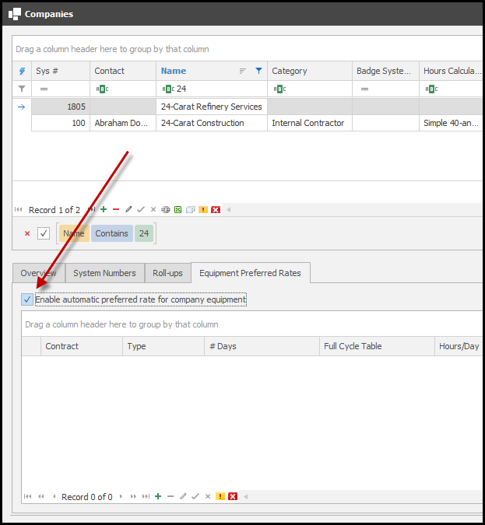

Another commonly used term in this release is, cycle. This refers to the period of time in which the equipment is used and preferred rates are calculated (28-day rolling, monthly [January]).

Creating a Preferred Rate Rule (Companies)
If the entire equipment list follows the same rate structure, it can be setup, one time, in the Companies table. Example: Every item meets the daily rate at 8 hours of use, or weekly rates are met at 3 days of use, or monthly rates are applied at 3 weeks of use. To add a preferred rate rule on the company level, click the plus sign (+). You can assign a contract if needed, then choose your cycle, calendar or rolling days. When choosing rolling days, enter the number of days in the cycle. Next set the number of hours that can be charged before the rate shifts to daily and the same for days to weeks and weeks to months. There are also additional Options to utilize when setting up your preferred rates based on contract information.

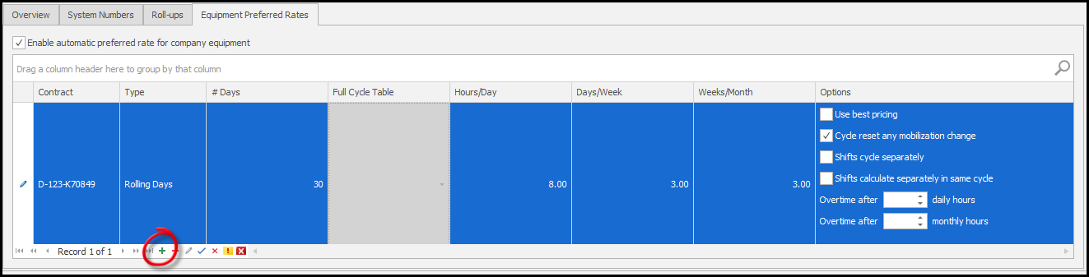

Options
The Use best pricing option changes the underlying preferred rates calculation to look at the rates on the equipment item to determine if a unit should be upgraded based on the ratios (hours/day, etc.) or table, but only if it is cheaper than than that unit x unit rate (hours x hourly rate, etc.).

The Cycle reset any mobizilation change makes it so that if a piece of equipment mobilizes a new cycle should be started the existing cycle should be early.

The Shifts cycle separately option makes it so that if reporting the same piece of equipment on different shifts, each shift will be treated as though it is a separate piece of equipment for cycling. This option disables Shifts calculate separately in same cycle.

The Shifts calculate separately in same cycle makes it so that if reporting the same piece of equipment on different shifts, each shift will create a sub-cycle with in the cycle for the given piece of equipment. This option disables Shifts cycle separately option.

If neither shift option is selected, then the night override rates are not used and any reported usage is comined for that date by unit, so a reported 8 hour day shift and 8 hour night shift will be treated as 16 hours for that date.

There are two options related to overtime, both of which use the new overtime rate on the Equipment Item Screen. The first applies in the case the hours reported on a date exceed the threshold the user sets and anything beyond that will use the Overtime Hourly rate for that item. The other option is for overtime after a threshold of monthly hours. In this a total is kept of the hours reported in cycle and if the threshold is reach all hours going forward will use the Overtime Hourly rate.

Overtime hours are an additional cost on top of the preferred rates that are calculated.

Creating a Preferred Rate Rule (Equipment)
In cases where the rate structure differs from item to item, the rule can be set on each item in the Equipment Items. In Equipment>Equipment Items, find the equipment item in the list and click on the Preferred Rates tab. By default, the items will be listed as Company Setting in the “Use automatic preferred rate selection” line. You can edit that selection to NO for material items that would not have preferred rates. Or you can select YES if this rate structure differs from the blanket company assignment that was already created. In the same process as above you will click the plus sign (+) and add a new preferred rate rule and assign the correct numbers in the fields for that item. In this case the item is billed at overtime rate after 200 hours in a month, so I have included that in this rule.
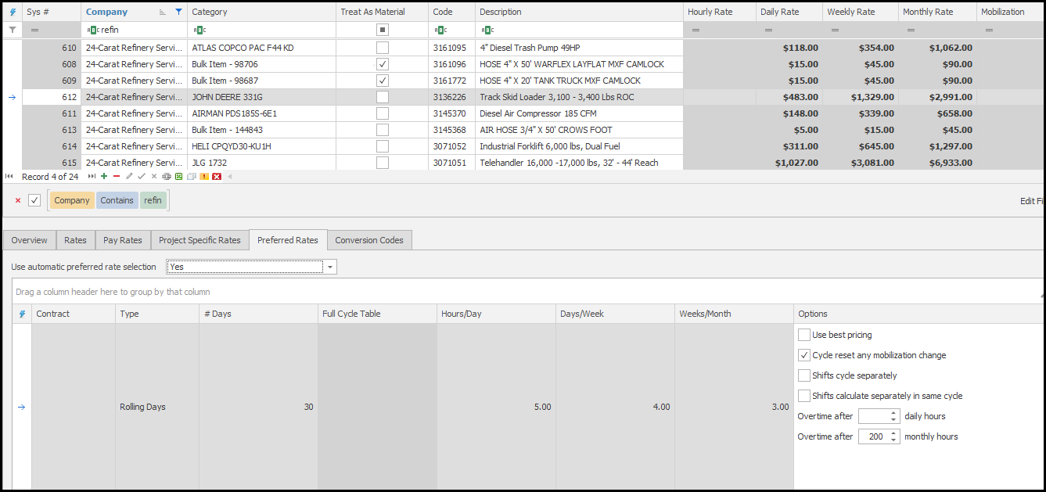
In the Rates tab you will find some new rate options that include overtime, override rates, and Is Tracking Hourly Rate. The tracking hourly rate is used to indicate that a piece of equipment is reported in hours for tracking purposes but contractually does not use hours and should always be upgraded to days or a greater unit.

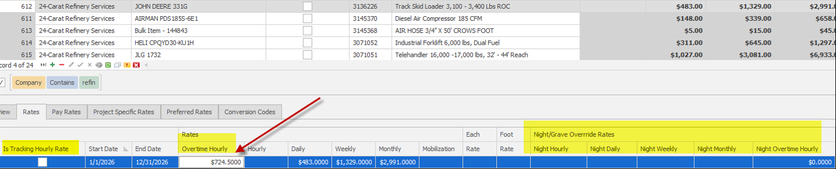

Import Review Screen/Analysis Screen Updates
When importing an equipment timesheet, you will find all new fields for Preferred Rates in the import review screen. In this example the reported hours are displayed and when a preferred rate rule is applied it will display in that column. At 5 hours this item rolls to a daily rate.
If you import a timesheet that includes weeks of daily entries, the software will calculate that on import. Showing the preferred monthly rate is applied, and is distributed by usage in each line so that distrubition of the cost is applied appropriately. Also there were more than 200 hours reported, so the overtime rate was applied for those hours.
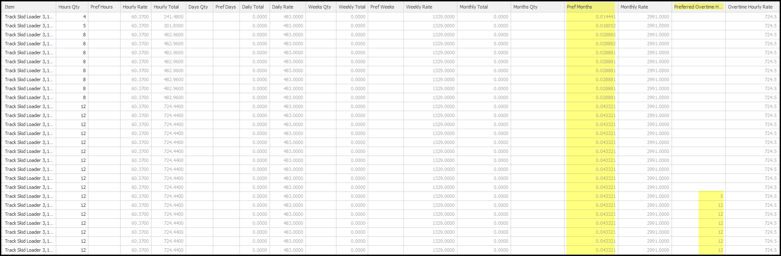

The calculation for preferred rates looks at the rates for a piece of equipment and after trying to upgrade a unit (hours to days, etc.) and if the upgraded unit does not have a rate it will go the the next smallest unit.

Changes and updates are also made in real time in the Analysis>Daily Entries>Equipment screen. These new fields are tacked on the end of the screen (seen on next page).

As new records are added the software will lookup existing records and make any necessary adjustments to meet the boundaries of the rule assigned. The software will also look up cycle dates and add new or correct previous cycle dates, as long as the cycle is not closed.
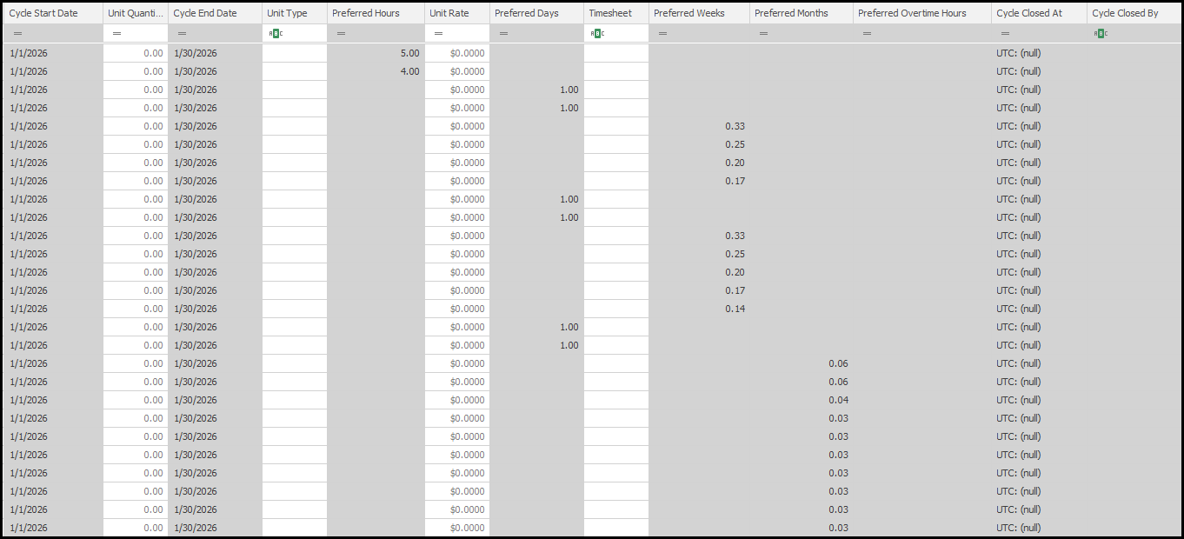

Full Cycle Table
In Equipment>Full Cycle Table you can create a table of usage to assign a company or equipment item. In some cases, a contract may define the exact usage conversions by days of use. You can replicate that here. When in use on the rule set on the company or equipment item this replaces the need for the ratio fields (hours/day, etc.)

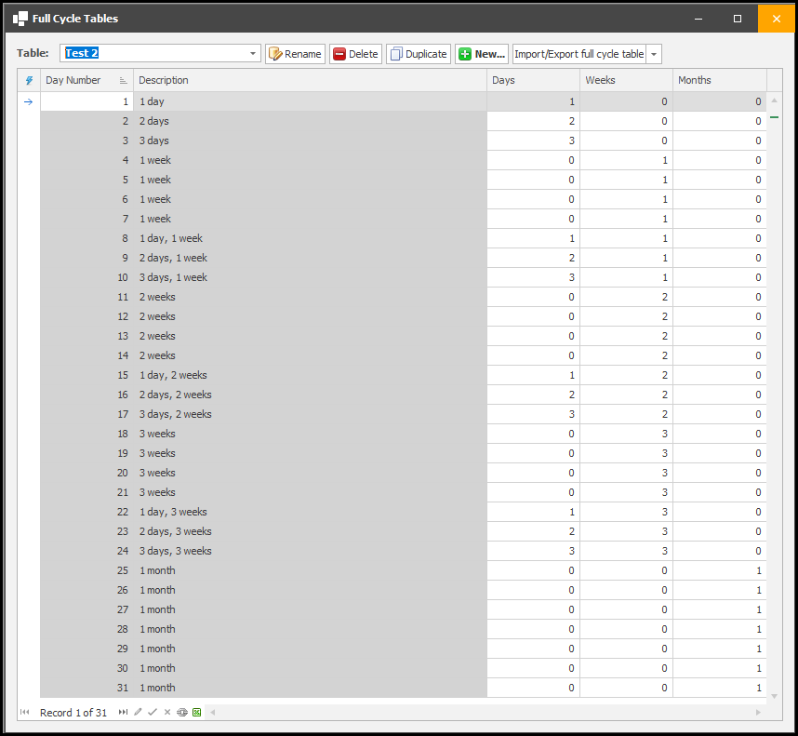

Dashboard
In Dashboard>Equipment Cycles all items that are subject to a preferred rate rule will display here. This dashboard is intended to provide a visual of all charges, the cycle dates, what was originally reported and the preferred rate that was applied. Approval status is available with hovering tool tips on the icons next to the cycle and eventually you will be able to package records from this screen as well.

For the status icons an empty icon denotes that no records are in that status, a partially filled icon shows some records have passed that status, and a fully filled icon mean all records have passed that status. These status denoted by these icons are:
- Auidited
- Verified
- Field Approved
- Approved
- Cycle Closed
- Service Entry (if used by the site)
- Billing Package
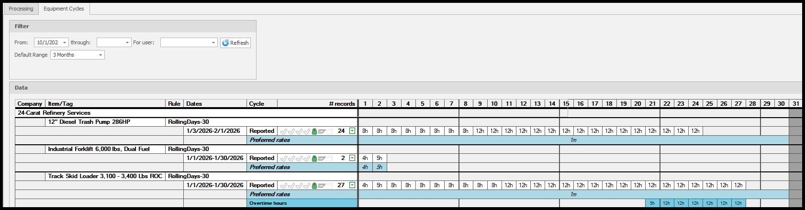

Dashboard actions
Similar to the processing dashboard there are several actions a user can do on a cycle by clicking on the down arrow button on a cycle (next to the # records). A user can view the records in the cycle in an anlysis screen or a Detailed Cost Report of those records. Additionally a user can close a close a cycle or close a cycle early. When a cycle is closed the equipment entries in that cycle will be locked and no further calculation will be performed and the entries can no longer be editted.

Closing the cycle will treat the use the cycle rule to determine the end of the cycle, and this operation should be done once records have been approved. Closing the cycle early by default sets the Cycle end date to the date of the last record unless specified otherwise by the user.

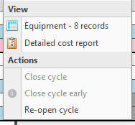

Reports
The Detailed Cost Report has been modified to reflect this new information as well. What will actually be charged remains in black text, reported or preferred. However reported data that is converted to preferred rates is shown in gray.
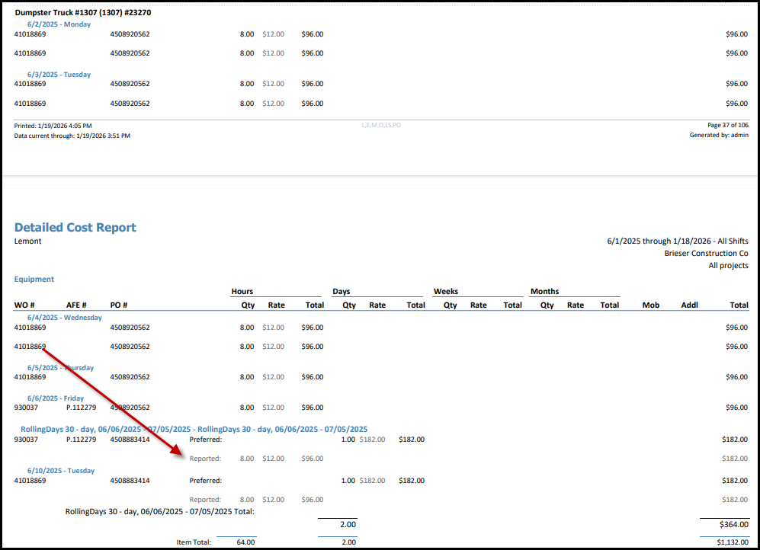

Additionally the Summary Cost Report has new columns for use related to equipment cycles and a new data column set has been created to compare reported equipment usage against the preferred rates.

